Requirement Analysis
Technology Stack (Architecture & Stack)
Date | 19 Feb 2026
Team ID | LTVIP2026TMIDS39481
Project Name | ShopSmart: Your Digital Grocery Store Experience

Technical Architecture:

The technical architecture for ShopSmart is designed using the MERN stack, ensuring a scalable, modular, and responsive full-stack solution for grocery shopping. The architecture consists of user-facing interfaces, application logic handled by server-side code, and persistent data storage through a NoSQL database. This architecture ensures a seamless flow of information and interactions for customers, sellers, and administrators.

Architecture Diagram:
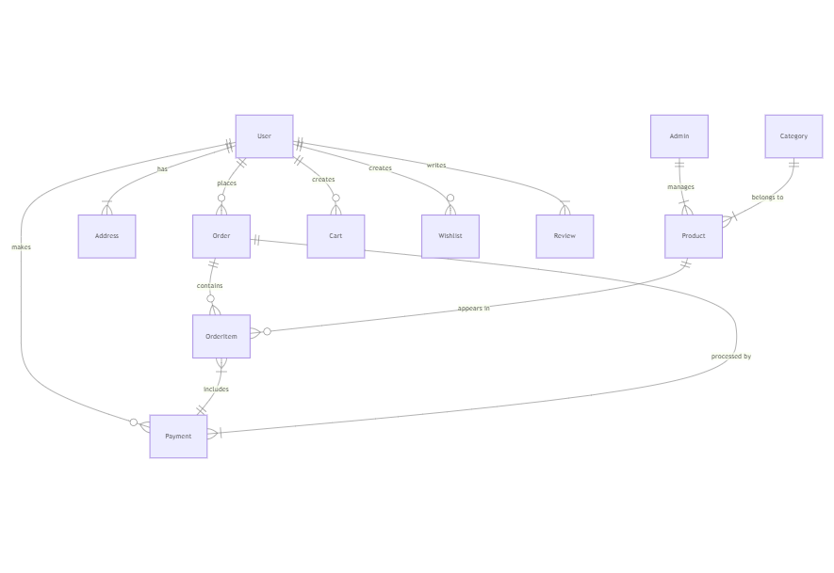
ER-Diagram:
Technical Architecture:
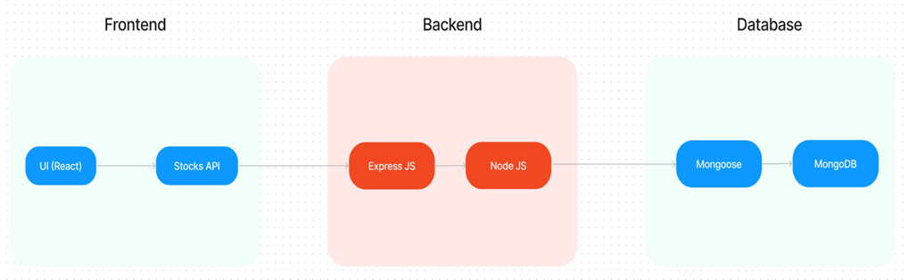
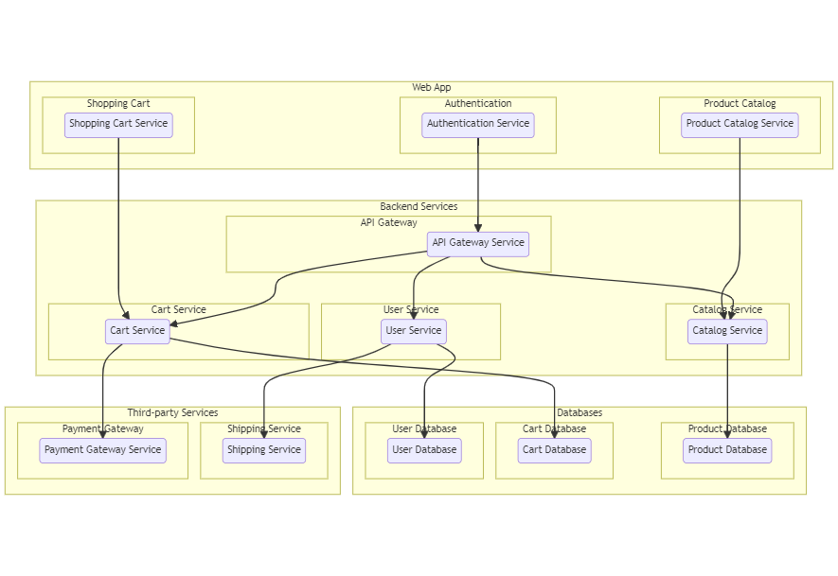

Table-1: Components & Technologies

S.No | Component | Description | Technology
1 | User Interface | Web UI for customers, sellers, and admins | HTML, CSS, JavaScript, React.js
2 | Application Logic-1 | User authentication, registration, role-based access | Node.js, Express.js
3 | Application Logic-2 | Order processing, cart handling, inventory management | Node.js, Express.js, Mongoose
4 | Application Logic-3 | Admin control panel with full CRUD operations | Node.js, Express.js
5 | Database | Persistent data storage for users, products, carts, orders | MongoDB
6 | Cloud Database | Optional for deployment (MongoDB Atlas) | MongoDB Atlas
7 | File Storage | Product images and static assets | Local filesystem or Cloudinary
8 | External API-1 | SMS/Email Notification for orders | Twilio API / Nodemailer
9 | External API-2 | (Optional) Payment integration | Razorpay / Stripe
10 | Infrastructure | Application deployment | Localhost, Vercel (frontend), Render (backend)

Table-2: Application Characteristics
S.No | Characteristics | Description | Technology
1 | Open-Source Frameworks | Used for frontend/backend development | React.js, Node.js, Express.js, MongoDB
2 | Security Implementations | JWT Authentication, Bcrypt password hashing, role-based access | JWT, Bcrypt, CORS, HTTPS
3 | Scalable Architecture | Modular design following a 3-tier architecture | MERN Stack, RESTful APIs
4 | Availability | 24/7 uptime goal, deployment on reliable services | Vercel, Render, MongoDB Atlas
5 | Performance | Fast API responses, optimized rendering, efficient DB queries | Axios, React Hooks, Caching (local)

